A Method to Characterize the Depth of a Shotgun Proteomics Experiment

Vic Spicer¹ and Ronald C. Beavis¹

¹Faculty of Health Sciences, College of Medicine, Department of Biochemistry and Medical Genetics

Abstract
A method was described that could be used to generate distributions that characterize the rate of assigning novel peptide and protein sequences in the data obtained from a shotgun proteomics experiment. These distributions could be used to predict the effect of changing experimental parameters on the number of identifications obtained by a similar experiment. The new parameters F_{c} and f_{c} were proposed as characteristic of the completeness or “depth” of any particular experiment in terms of the number of proteins or peptides found.
Introduction
Shotgun proteomics experiments have become commonly used methods to determine the proteins present in a sample [1]. It is also used to determine protein post-translational modifications, protein-protein interactions and to understand changes in protein concentration caused by a wide range of stimulus conditions.
This type of experiment involves cleaving a protein sample into peptides (most commonly using trypsin), chromatographic separation of the peptides using tandem mass spectrometry to generate fragment ion mass spectra characteristic of the individual peptide sequences. The fragment ion spectra are then assigned to peptide sequences and the proteins present in the original sample are inferred from assembling these peptide sequences using the protein sequences known from their gene/mRNA sequences as a scaffold. Experimental designs range from taking a few thousand to over one million spectra and may require combining the results from multiple chromatographic separations.
An unresolved question in the design of shotgun proteomics experiments and their subsequent bioinformatics analysis is whether the number of mass spectra obtained from a particular experiment were sufficient to fully characterize the protein compliment present in the original sample that are present above the level of detection. There is no simple way to determine whether obtaining more spectra using a particular protocol would result in identifying significantly more proteins or peptides. The cost and difficulty of proteomics experiments often scale with the number of mass spectra required, so quantifying the completeness of an experiment has considerable practical implications for research studies.
This paper describes a simple Monte Carlo calculation [2] capable of answering questions of the type: "If I change the number of spectra used for a particular experiment, how does that effect the number of proteins and peptides I will find?". The method uses an existing data sets and it generates a distribution that can be either interpolated or extrapolated to provide an unambiguous prediction without requiring further experiments. It also describes the use of this method to produce parameters than can be used to judge the completeness of an experimental protocol, i.e., the extent to which the protocol detects the proteins and peptides available above their levels of detection.
Method
The calculation requires an existing list of confident peptide-spectrum matches (PSMs) obtained from a relevant set of experimentally obtained fragment ion mass spectra. The search algorithm used is not important, so long as it is possible to statistically separate confident PSMs from potentially stochastic false positive ones.
The distribution necessary to make predictions about the completeness of selected data set is constructed by creating an array of the confident PSMs in the order in which they were obtained experimentally. If the number of confident PSMs is N, then this list is represented as a simple array, with integer indexes ranging from 1 to N. Then, select a sampling number S such that S << N. Using a good random number generator, select n=S unique random integers in the range 1 - N. Select the PSMs with indexes corresponding to those n numbers and calculate the number of unique peptides p(n) and unique proteins P(n) obtained. Record the values of n, p(n) and P(n). Repeat this process gradually increasing the value of n progressively until it approaches N, e.g,. n = 2S, 3S ... N-S, selecting random sets of integers and recording the values of n, p(n) and P(n).
The resulting discrete functions p(n) and P(n) represent what would have happened if the experiment had recorded fewer MS/MS spectra across the chromatographic conditions used, resulting in n rather than N PSMs.
It was found to be practically useful to run the method multiple times and produce p(n) and P(n) that were the average of these multiple runs, both to reduce scatter in the distributions and to determine whether the runs were converging towards a mean. In the cases tested, averaging together 10 runs seemed to be adequate to produce smooth distributions and to demonstrate convergence. An average of 10 runs was used to generate the figures and tables below.
In addition to the simple P(n) and p(n) distributions, determining the rate of finding new protein or peptides identifications as a function of increasing n was easily calculated. The rate of adding new proteins, F(n), was calculated from P(n) using the formula:
F(n_{i}) = (P(n_{i}) - P(n_{i-1})) / (n_{i} - n_{i-1})
The rate of adding new peptides, f(n), was calculated from p(n) using the formula:
f(n_{i}) = (p(n_{i}) - p(n_{i-1})) / (n_{i} - n_{i-1})
The discrete value of the F(n) and f(n) distributions corresponding to the maximum value for n were given special symbols, F_{c} = F(n_{max}) and f_{c} = f(n_{max}).
It should be noted that this type of Monte Carlo calculation requires a very good random number generator when using large data sets. Any random number generator that is considered secure for cryptographic purposes is sufficient for this type of calculation, but it is important that any software developed for this purpose is tested to determine whether the behavior of the random number generator is affecting the results. The current work used the ISAAC algorithm as implemented in the PERL module Math::Random::Secure.
Results and Discussion
Figure 1 was obtained by applying the method described above to a medium-sized proteomics data set that contained 28,268 PSMs out of 72,832 candidate spectra (see GPMDB accession number GPM64510027832 for details). The protein distribution P(n) (Figure 1A) indicated that as the number of PSMs sampled increased, the number of unique proteins obtained increased, but increase slowed significantly at larger values of n. The peptide distribution p(n) (Figure 1B) also showed an increase in unique peptides found as n increased, but with only a very gradual change in the rate of increase over the full range of n values.
Figure 2A and 2B show the rate of change distributions for the same data set. These distributions quantify the rate of discovering new proteins and peptides as a function of the number of PSMs included.
Figure 2A, a plot of the F(n) distribution, demonstrated that for small values of n, the number of new proteins discovered was quite high: for the smallest value of n, F(n₁) = 0.6 implies that 60% of the PSMs discovered a new protein. The distribution dropped off quite quickly with increasing n, to a value of F_{c} = 0.025 for the largest n value. This result implied that the maximum rate of protein identifications that could be obtained by simply taking more spectra in this particular experiment would be 2.5%, i.e., it would require 40 extra PSMs to find a single new protein. This distribution would therefore predict that if the experiment was redesigned so that the number of PSMs was doubled (and everything else remained the same), the maximum number of new protein identifications would only be 2.5% larger than the original experiment.
Figure 2B, a plot of the f(n) distribution, when compared to Figure 2A, indicated that the functional form for peptides was quite different than it was for proteins. The value of f(n₁) = 0.93 was higher and while f(n) decreased with increasing n, the decrease was nearly linear, ending at f_{c} = 0.5. This value implied that the maximum rate of peptide identifications that would be expected by increasing the number of PSMs was 50%, a rate 20× higher than the protein F_{c}. Therefore, simply taking more spectra without other changes in the experimental design would be much more likely to discover new peptides than new proteins and would result in improved protein sequence coverage without adding many new proteins to list.
Figures 3 and 4 show the distributions determined from a multidimensional chromatography experiment in which many more spectra and PSMs were obtained, 183,030 PSMs from 338,043 candidate spectra (see GPMDB accession number GPM64520008626 for details). Comparing Figures 1 and 3, the P(n) and p(n) distributions have similar functional form, even though the number of proteins and peptides identified was larger in Figure 3. Comparing Figures 2 and 4 shows that while F(n) in Figure 2B and 4B have similar shapes, the f(n) function in Figure 4B had considerably more deviation from linear than Figure 2B.
The using the protein-based F_{c} statistic to compare these two experimental protocols through their resultant data sets provides some insight into these experimental designs. F_{c} = 0.025 (1D chromatography) versus F_{c} = 0.005 (2D chromatography) indicate that both studies were nearly complete (or deep) with respect to the level of detection possible for proteins, given the experimental design. We would propose a definition of the completeness (or depth) of an experiment based on this statistic would be: if doubling the number of PSMs results in an increase of the number of identified proteins of less than 5% (F_{c} ≤ 0.05), then the experiment was “complete”.
Examining the peptide-based f_{c} for these two protocols leads to quite a different conclusion. f_{c} = 0.5 (1D chromatography) versus f_{c} = 0.14 (2D chromatography). Although the second protocol has done better at obtaining unique peptide sequences from the PSMs available, using a similar definition of peptide completeness (f_{c} ≤ 0.05) neither protocol could be considered to be “complete” with respect to unique peptide sequences available above the level of detection.
The finding that existing publicly available data sets were more likely to pass the protein test F_{c} ≤ 0.05 than the peptide test f_{c} ≤ 0.05 turned out to be quite general: in the 350,000 data sets currently held in GPMDB, none pass the peptide test.
Conclusions

References
- Yates JR 3rd, The Revolution and Evolution of Shotgun Proteomics for Large-Scale Proteome Analysis, J Am Chem Soc. 2013 Feb 6;135(5):1629-40. doi: 10.1021/ja3094313.
- Harrison RL, Introduction To Monte Carlo Simulation, AIP Conf Proc. 2010 Jan 5; 1204: 17–21, doi: 10.1063/1.3295638
- Schiller HB, Fernandez IE, Burgstaller G, Schaab C, Scheltema RA, Schwarzmayr T, Strom TM, Eickelberg O, Mann M, Time- and compartment-resolved proteome profiling of the extracellular niche in lung injury and repair. Mol Syst Biol. 2015 Jul 14;11(7):819. doi: 10.15252/msb.20156123
- Pinto SM, Manda SS, Kim MS, Taylor K, Selvan LD, Balakrishnan L, Subbannayya T, Yan F, Prasad TS, Gowda H, Lee C, Hancock WS, Pandey A, Functional annotation of proteome encoded by human chromosome 22. J Proteome Res. 2014 Jun 6;13(6):2749-60. doi: 10.1021/pr401169d.

Figure captions
Figure 1. Discrete functions generated from GPM64510027832 [3]: (A) identified protein distribution, and (B) identified peptide distribution as a function of the number of PSMs sampled.
Figure 2. The rate of change discrete functions generated from GPM64510027832: (A) identified protein distribution, and (B) identified peptide distribution as a function of the number of PSMs sampled, F_{c} = 0.025 and f_{c} = 0.5.
Figure 3. Discrete functions generated from GPM64520008626 [4]: (A) identified protein distribution, and (B) identified peptide distribution as a function of the number of PSMs sampled.
Figure 4. The rate of change discrete functions generated from GPM64520008626 : (A) identified protein distribution, and (B) identified peptide distribution as a function of the number of PSMs sampled, F_{c} = 0.005 and f_{c} = 0.14.
Figure 5. The same distributions shown in Figure 4 represented in a log₁₀-log₁₀ plot. The best fit linear extrapolation equations were (A) log(F(n)) = -1.21 log(n) + 4.05 and (B) log(f(n)) = -0.70 log(n) + 2.85.

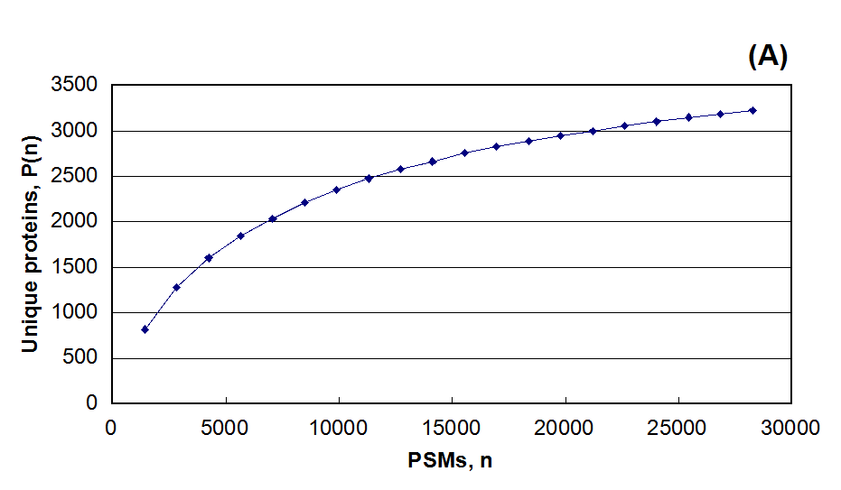
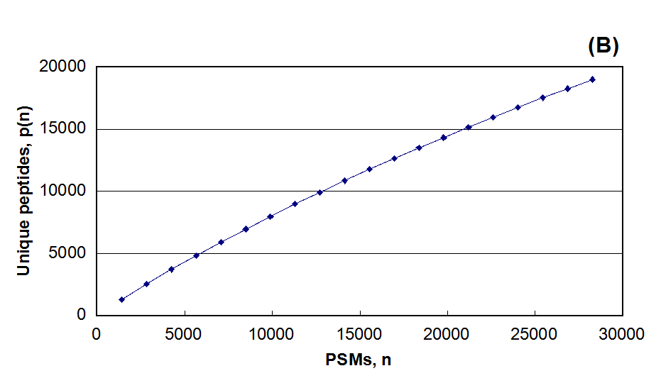Figure 1. Discrete functions generated from GPM64510027832 [3]: (A) identified protein distribution, and (B) identified peptide distribution as a function of the number of PSMs sampled.

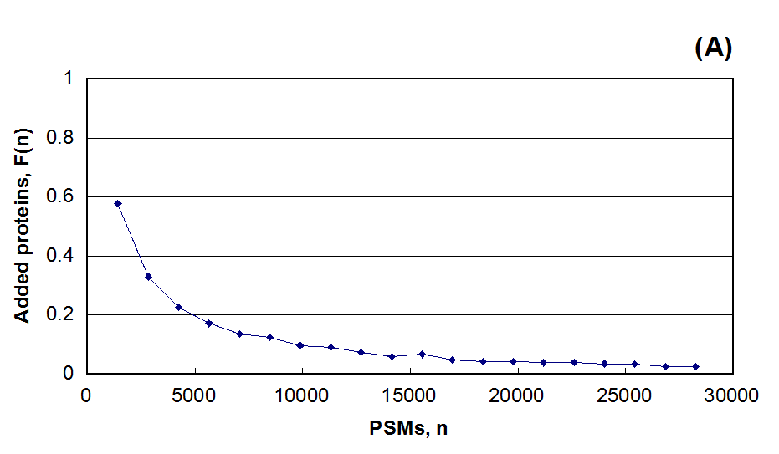
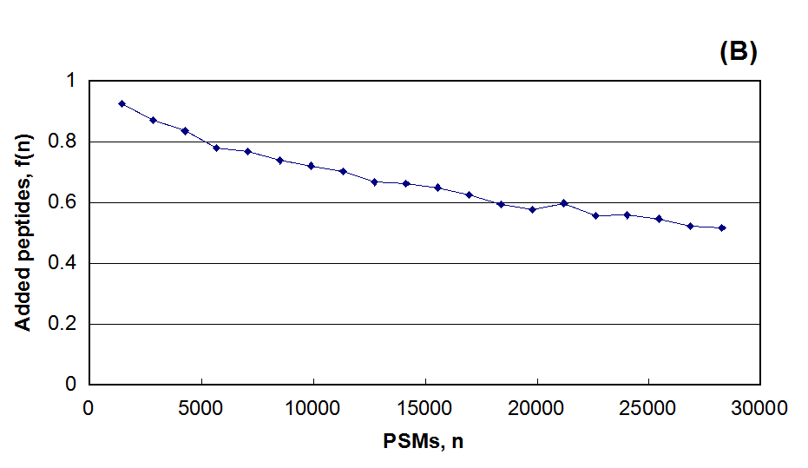
Figure 2. The rate of change discrete functions generated from GPM64510027832: (A) identified protein distribution, and (B) identified peptide distribution as a function of the number of PSMs sampled, F_{c} = 0.025 and f_{c} = 0.5.
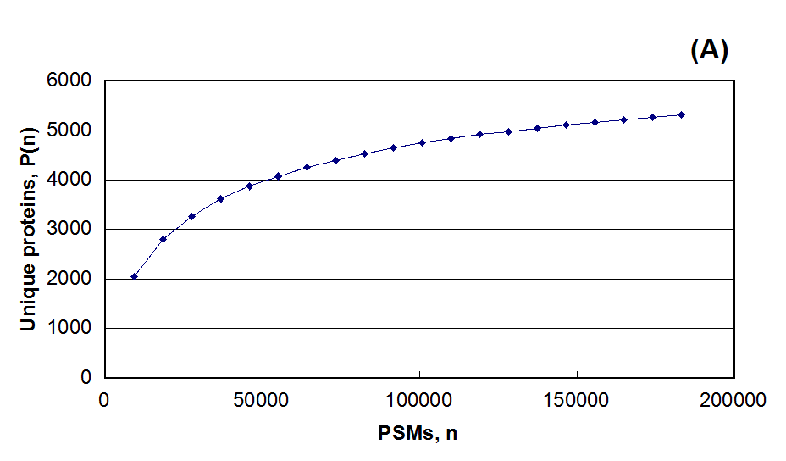
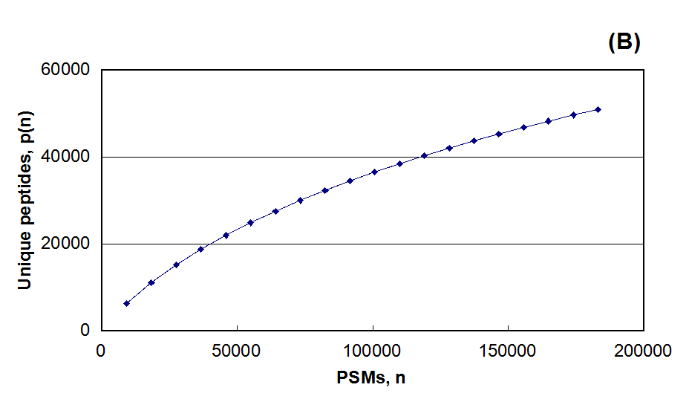
Figure 3. Discrete functions generated from GPM64520008626 [4]: (A) identified protein distribution, and (B) identified peptide distribution as a function of the number of PSMs sampled.

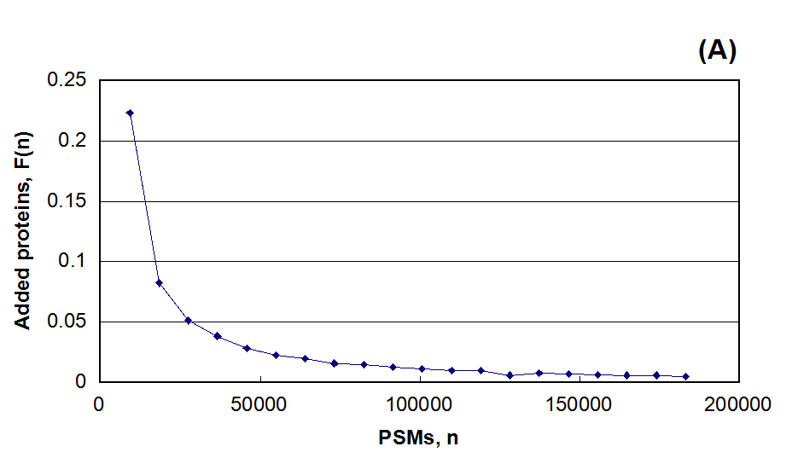
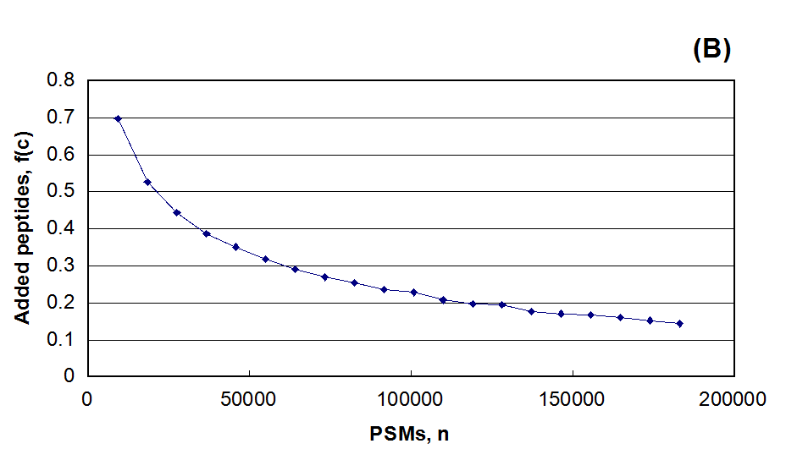
Figure 4. The rate of change discrete functions generated from GPM64520008626: (A) identified protein distribution, and (B) identified peptide distribution as a function of the number of PSMs sampled, F_{c} = 0.005 and f_{c} = 0.14.

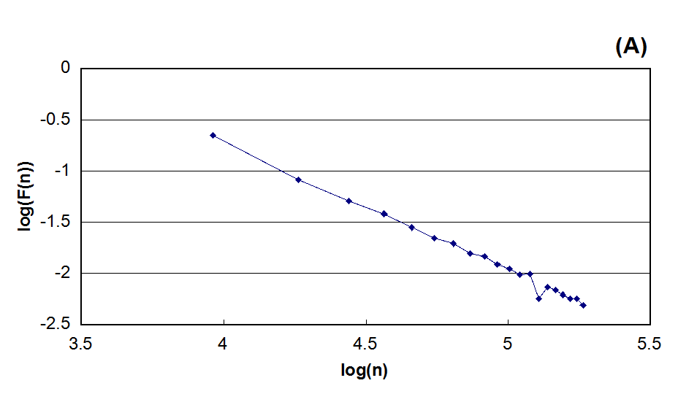
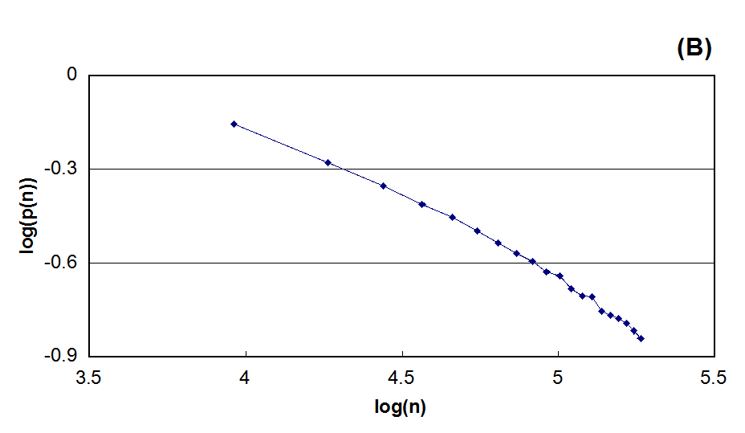

Figure 5. The same distributions shown in Figure 4 represented in a log₁₀-log₁₀ plot. The best fit linear extrapolation equations were (A) log(F(n)) = -1.21 log(n) + 4.05 and (B) log(f(n)) = -0.70 log(n) + 2.85.

